It enables a business to maximize the speed of its delivery of a product or service, from initial idea to production release to customer feedback to enhancements based on that feedback. Q

needed to test the business vision or value, and then continuously

adapting and adjusting based on customer feedback.

To achieve these goals, organizations measure progress, find

out what customers really want, and then shift direction by

updating their business plans accordingly, allowing them to

make continuous trade-off decisions in a resource constrained

environment.

Software delivery efforts in an enterprise involve large numbers

of cross-functional teams, including lines-of-business

owners, business analysts, enterprise and software architects,

developers, QA practitioners, operations personnel, security

specialists, suppliers, and partners. Practitioners from these

teams work on multiple platforms and may be spread across

multiple locations. Collaborative development enables these

practitioners to work together by providing a common set of

practices and a common platform they can use to create and

deliver software.

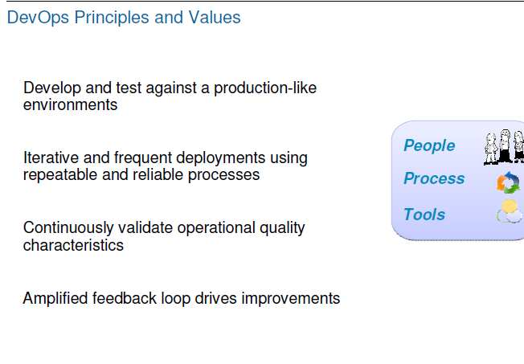

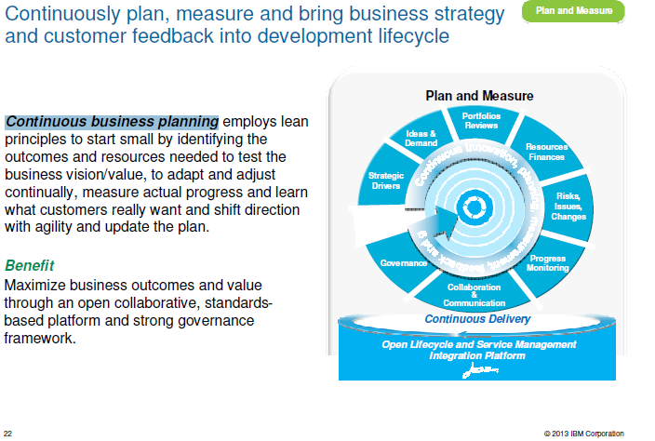

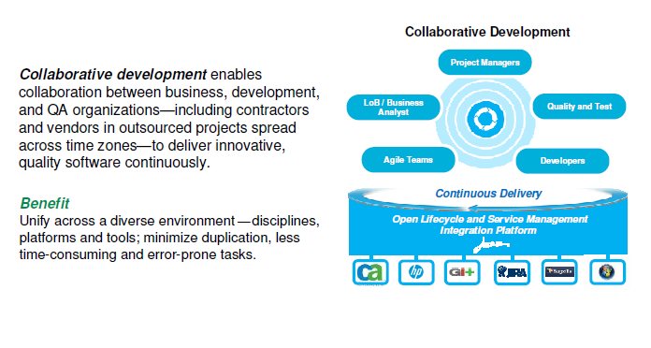

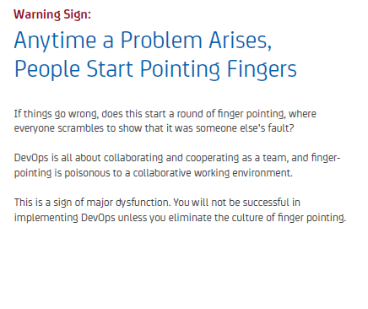

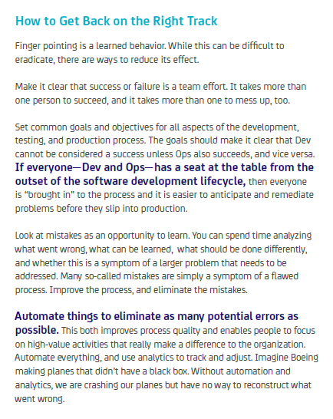

|  |  |
| --- | --- |
| Mercurial |  |
| Git |  |
| Subversion uses  FSFS | Default |
| Berkeley DB | Originally |

,

Subversion uses its own [FSFS](http://svnbook.red-bean.com/en/1.7/svn.reposadmin.planning.html#svn.reposadmin.basics.backends.fsfs) database. It's not a database in the relational database sense. It's a filesystem-based method of storing repository contents.

"FSFS" is the name of a Subversion filesystem implementation, an

alternative to the original Berkeley DB-based implementation.